## Criterion D: Product design—Requirements

The notepad used to check the requirements with the client after the first interview:

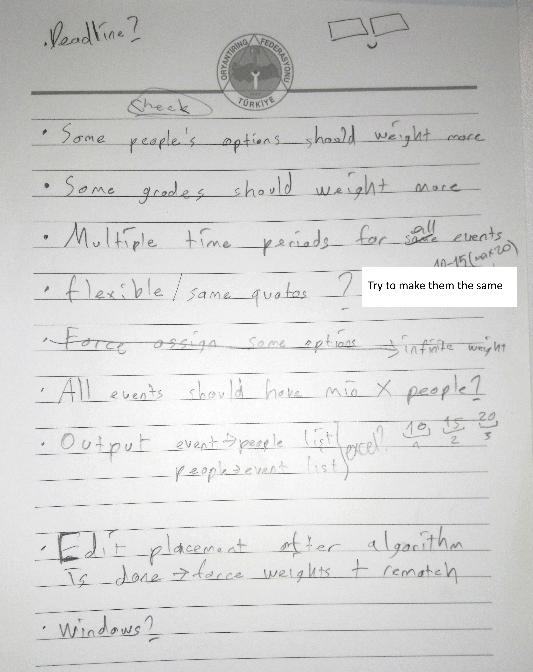

## Overall structure of the People UI

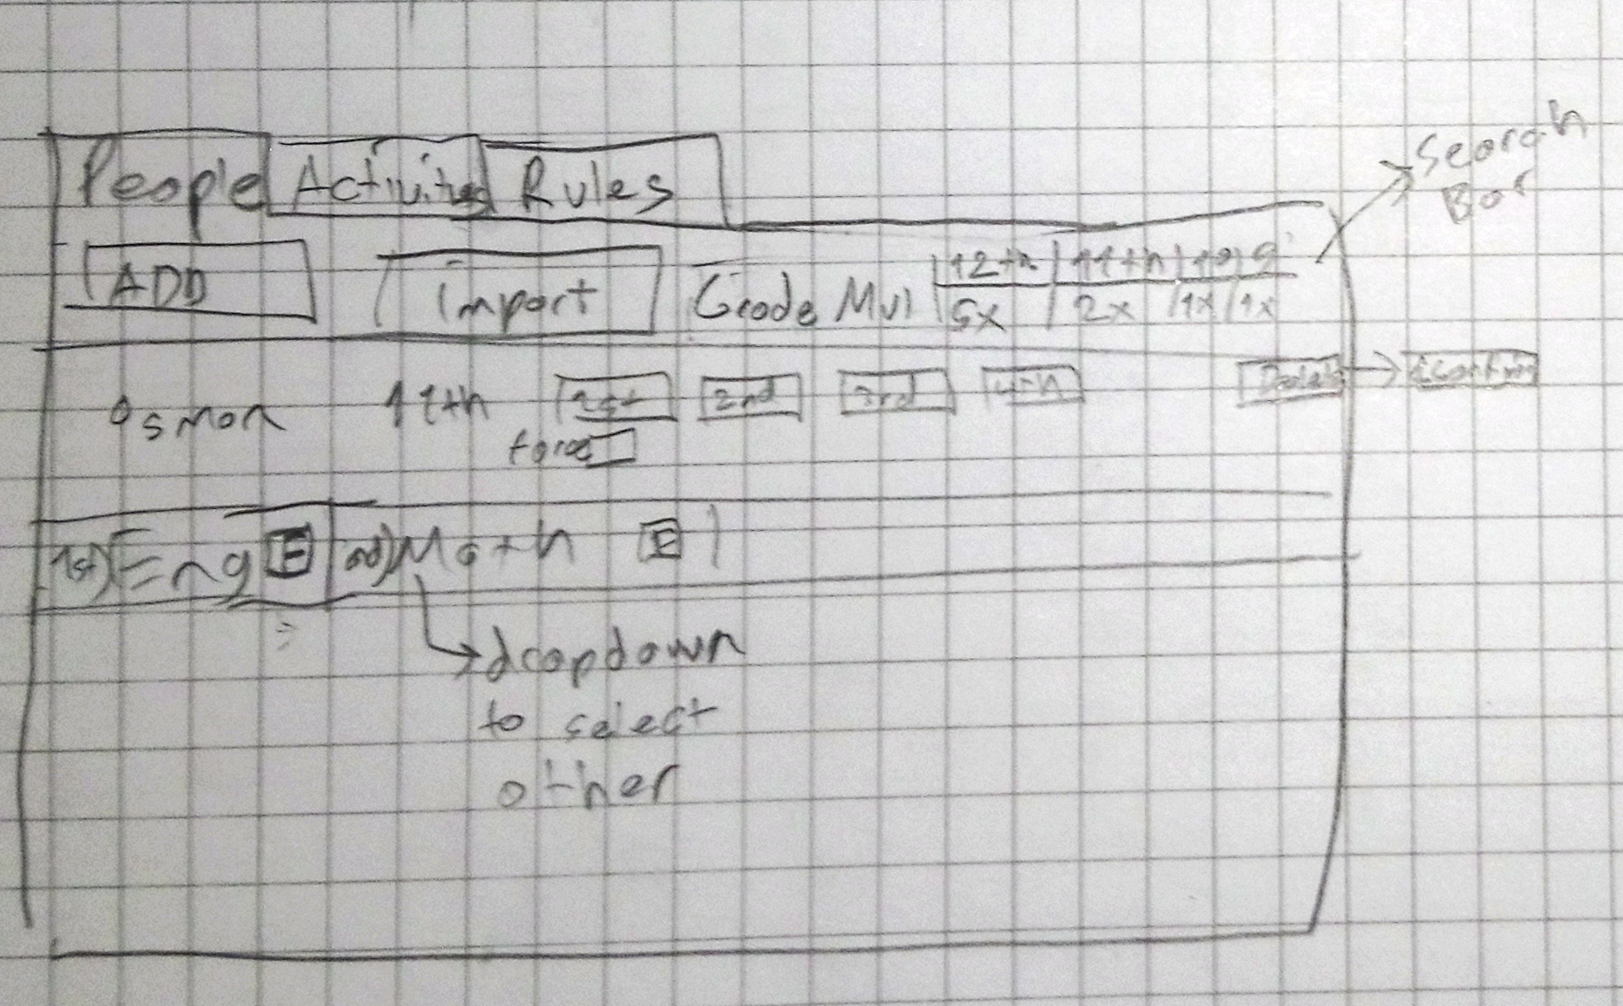

## Overall structure of the Activity UI

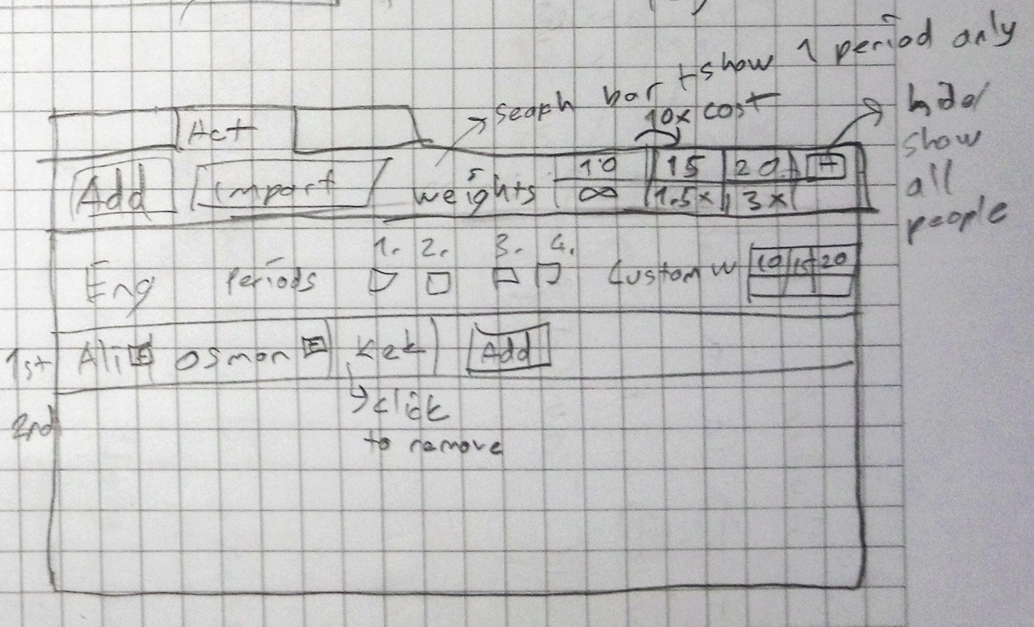

## Internal Code Structure

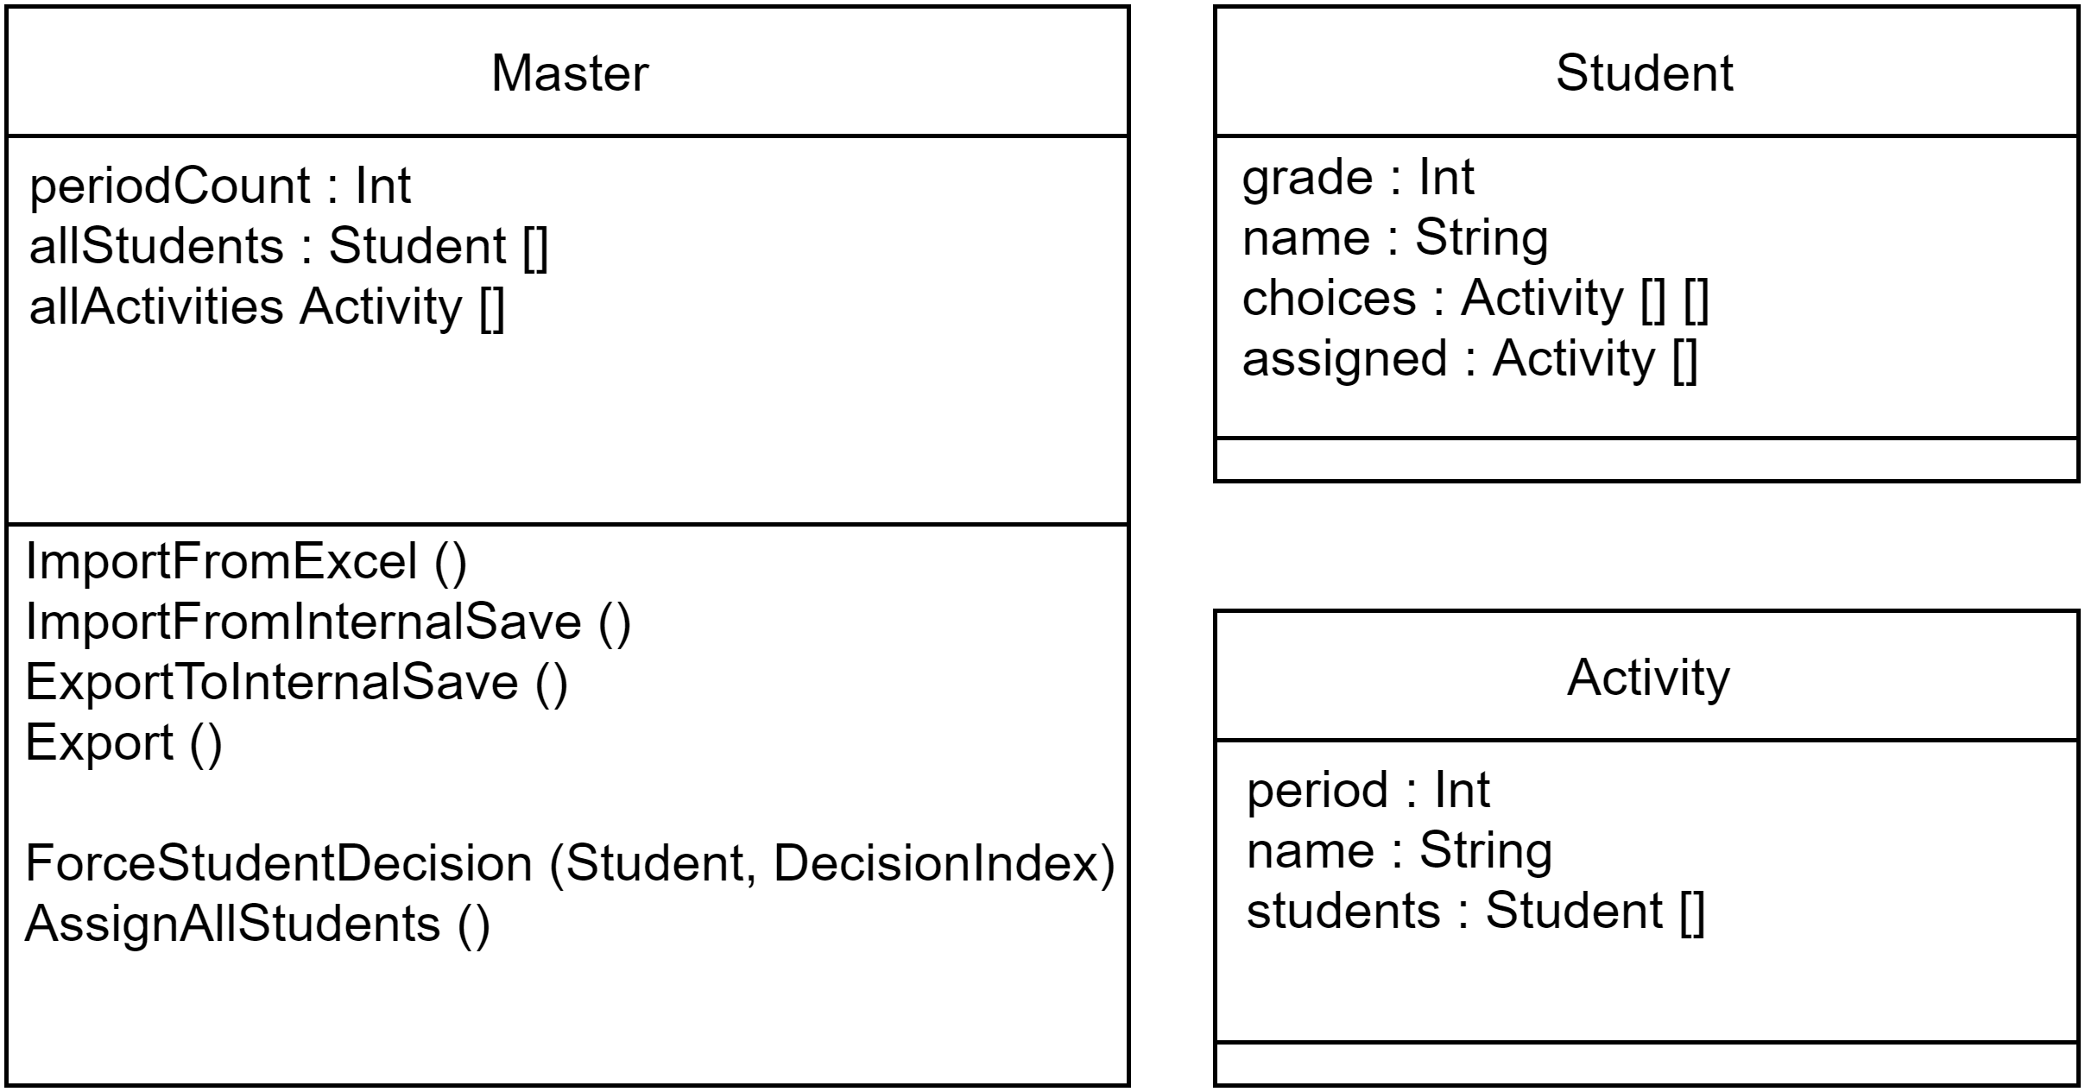

### List of resources and techniques

|  |  |
| --- | --- |
| **Resources** | **Details** |
| Stack Overflow (<https://stackoverflow.com>) | A forum which people can ask and answer various coding related questions. |
| OpenPyXL Documentations (<https://openpyxl.readthedocs.io>) | The documentation to the excel library I will be using for my project |
| Tkinter Manual (<https://www.tcl.tk/man/tcl8.5/>) | The manual to the Tkinter UI library I will be using for my project |
| Python Documentation (<https://docs.python.org/3/>) | General Python documentation |
| Effbot Tkinterbook (<http://effbot.org/tkinterbook/>) | A helpful site about the Tkinter library, as the Tkinter manual can be hard to use. |

|  |  |
| --- | --- |
| **Techniques** | **Details** |
| Use of Python | The application will be coded with Python |
| UI | The application will have a UI with buttons and tabs. |
| Classes | The application will have multiple classes |
| Functions with parameters, Arrays, loops, if-then | The application will use functions with parameters, arrays, loops, if-then and other programming concepts. |

## Test plan

|  |  |  |  |  |  |  |
| --- | --- | --- | --- | --- | --- | --- |
| Test item | Test data | Part of system tested | Expected outcome | Actual outcome | Comments | Ref in product |
| **Cover page testing – REQUIRED ELEMENT FOR CRITERION G** | | | | | | |
| **Web pages load from the cover page in three different locations** | **File naming to ensure home page is called Index.htm** | **Links on cover page are relative** | **Loads as required from 3 different locations** |  |  |  |
| **Product testing** | | | | | | |
| Student and Seminar info importing | Try to import a specifically formatted excel file | Importing | All data in the file is imported correctly | Yes |  |  |
| Minimum & Maximum Student requirements for the seminars can be changed | Try to change the minimum & maximum student requirements | Settings | The values can be changed properly | Yes | The settings can be changed from a different file |  |
| Students can be force assigned to activities | Try to force assign some students | Assigning | Every student can be properly force assigned | Yes | This action computationally expensive (slow) |  |
| Student grades are taken into consideration when assigning to activities | Check student assignments with different grades | Assignment algorithm | High grades are assigned to their top choices more commonly | Yes | Sometimes behaves unexpectedly |  |
| The algorithm correctly assign students | Try the algorithm with a variety of student configurations | Assignment algorithm | The students are assigned correctly | Yes | Some students were assigned very badly |  |
| Students can be reassigned after the algorithm is run | Try to reassign students after running the algorithm | Assigning | Every student can be reassigned | Yes |  |  |
| The algorithm can run multiple times | Try to run algorithm again after force assigning different students | Assignment algorithm | Algorithm can run any number of times | Yes |  |  |
| The assignments can be exported | Try exporting the assignments after running the algorithm a few times with different students | Exporting | The exported file is as expected | Yes |  |  |
| The UI is working and correct | Check the UI after various events | UI | The UI works as expected | Yes |  |  |
| Search bar | Try to search students | UI | The search bar works correctly to change the UI to show only the wanted students | Yes |  |  |

## Agreement of client



**Client: Ayşin Zeynep Ertaş**

I confirm that the requirement specification meets my needs and the designs above are appropriate for the creation of the product.